Lab 5 ENEL 453

By :

Taha Ghazaly 30018367

Aaron Dalik 10136967

Overview:

Using a VGA display to launch signals to play a reaction game.

Uses a LSFR in order to obtain random values as to when to start the game,

Uses bars to maintain the score of each player when a player wins a round, the bars height increases

When a player wins the winning player is displayed and the game is restarted once again.

Creative component:

This game can be played using Bluetooth through a phone using a self-developed BLE Bluetooth app and a BLE Bluetooth chip.

Furthermore, the winner’s average score is displayed after the end of the game using a BCD to binary conversion to calculate the average then a binary to BCD conversion to display it.

A simple tune can be played as a game start signal as well as the VGA display.

Can accommodate simple VGA art as well as basic animations using For- Generates loops for VGA art

Modular design makes it easy to add more modes/ versions of the game.

Top Level RTL:

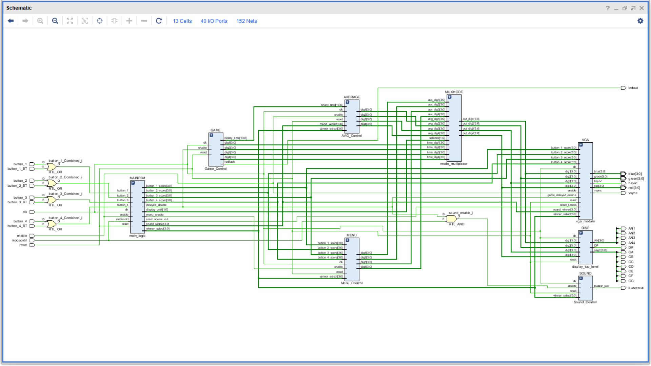

Overview:

